***Functionality Bug 1🡪DONE***

Go to the Task Specifics Screen

DO NOT ADD A COMMENT….

Click on the Add Comment Now button, if there is no comment or the comment box is empty the empty line is still added to the Existing Task Specifics box – See Task A0020 for an example

You can see the following

**####Bob Samual has added the following comment to this Task on 15 Apr 2020####   
####Bob Samual has added the following comment to this Task on 15 Apr 2020####   
####Bob Samual has added the following comment to this Task on 15 Apr 2020####**

But you can see there are no comments……

***Functionality Bug 2🡪DONE***

Click on the + to add a progress file.

Drag and Drop a file – and click on submit.

The file is submitted perfect

Now click on the + to add ANOTHER file

You can not do it – you keep getting this

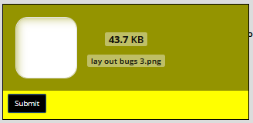

To get rid of this you need to leave the screen or re-load it!

***Functionality Bug 2🡪DONE***

Click on New Task

Scroll down the bottom of the new task screen – it says “1 files are ready to upload.”

To get rid of this you need to re-load task manager….

***Functionality Bug 3🡪DONE***

Click on the search tab, in the search tab there is Due Date and Creation Date. If there is nothing loaded on the screen you get a truncated date box

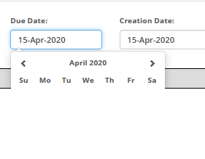

But the date boxes load fine when you have done a search

**Functionality Bug 4**

You are using these fancy new controls for check boxes 

They are nice the look cool but the rest of the system uses normal check boxes – did you use a different developer for this system ???

You do not need to change this I just need to know if you plan on using these controls from now on?